**Table relationships**

**Delete all existing table relationships**

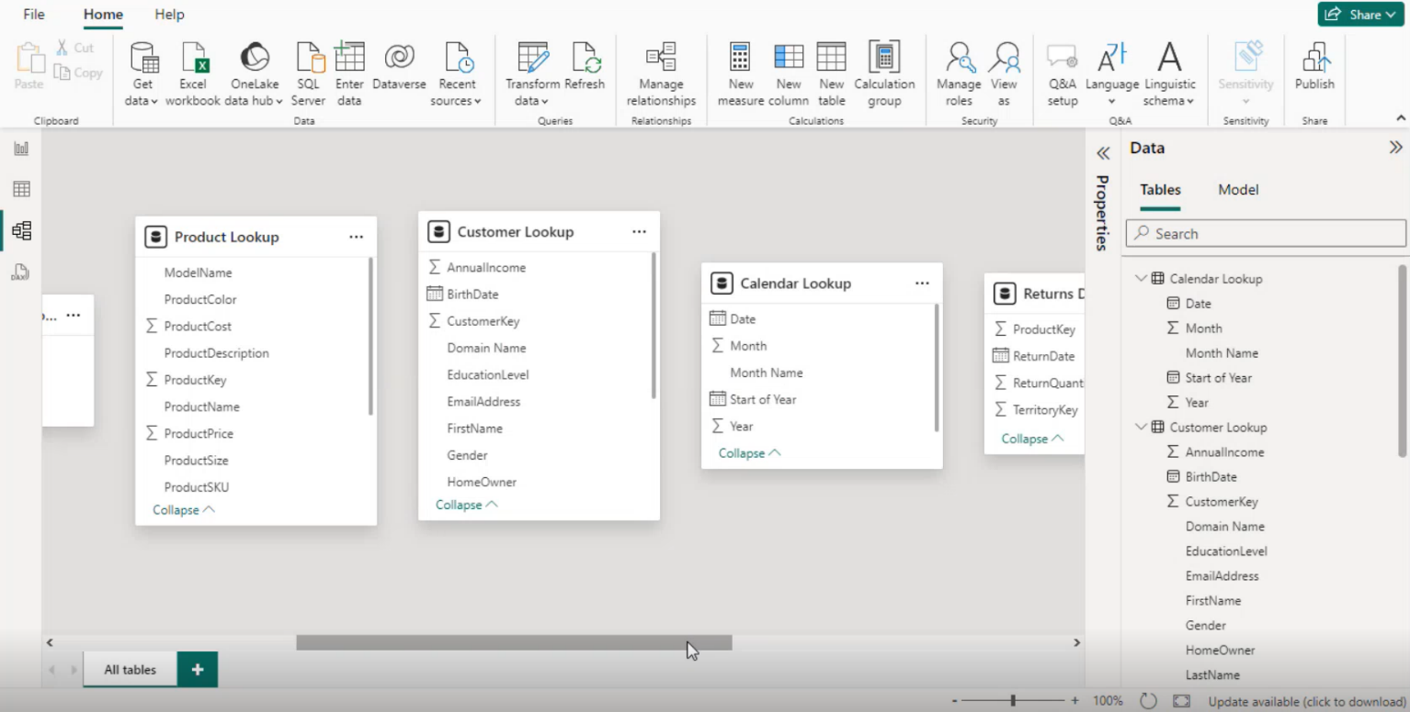

**Create a star schema by creating relationships between the sales, calendar, Customer, Product and territories tables**

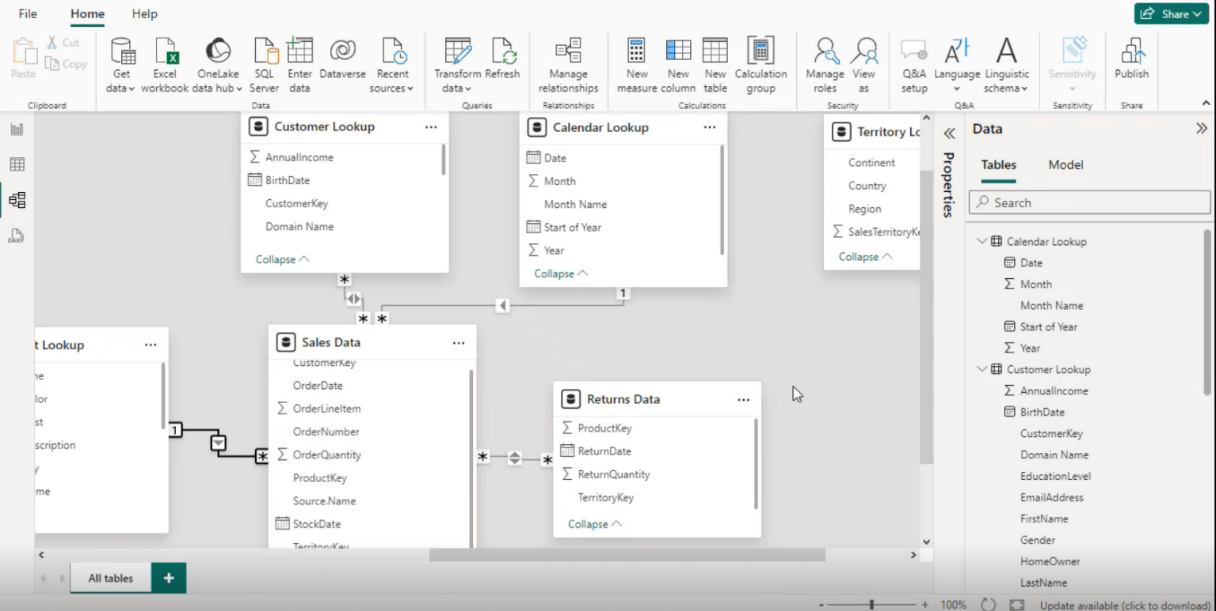

**Connect all three product tables in a snowflake schema**

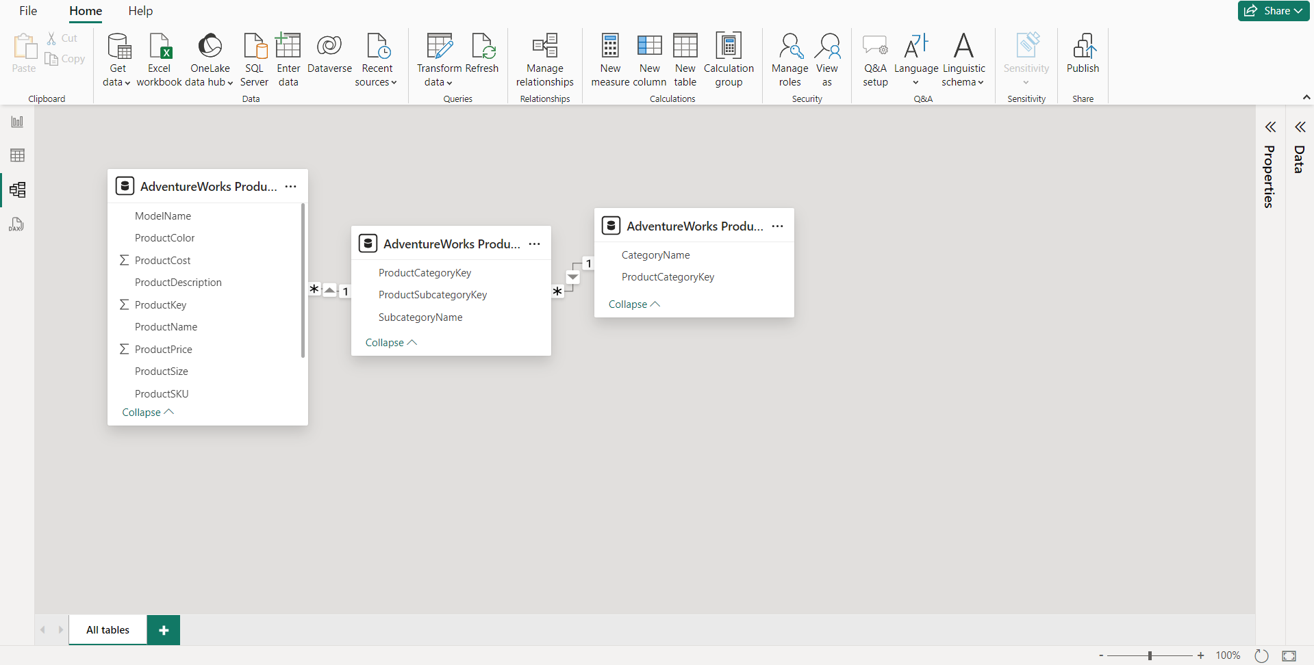

**Use the matrix visual to confirm that you can filter order quantity values using fields from each dimensions table**

